Week12_Lab9

Group22

106502531 洪仲杰

106502532 蔡沛宏

Description:

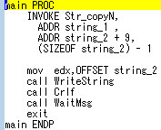

Main proc:

Invoke Str_copyN, and use parameter addr string_1,

addr string_2 + 9, (sizeof string_2) – 1

eventually, write string

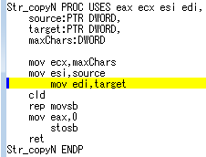

Str_copyN proc:Push eax,ecx,esi,edi into stack

parameter source = addr string_1, target = addr string_2 + 9,

maxChars = (sizeof string_2) – 1

ecx = maxChars(counter for rep), esi = source, edi = target

clear direction flag(direction = forward)

repeat movsb until ecx is 0

set eax = 0 and store eax at [edi]

Result:

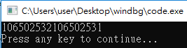

Review:

Today’s assembly language class, we learned how to make a structure just like we’ve used in C++. Also, we learned lod and sto, which can load or store something from memory at esi to eax(ax/al)register. Finally, we use stosb to achieve string copying and complete our lab9 homework.